HRIS: THE HUMAN RESOURCE INFORMATION SYSTEM
201 MODULE

TABLE OF CONTENTS

- System Features 4
- List of Common Buttons 4
- How To’s
  - Log In Page 4
  - Parts of the Main Screen 5
    - Maintenance 6
      - Change Password 7
      - Company 7
      - Branch 8
      - Division / Department / Section 8
      - Allowance Types 10
      - Loan Types 11
      - Tax Exemption Unit 11
      - Holiday Calendar 12
      - Bank 12
      - Day Types 13
      - Payroll Period 13

    - Personal Profile 14
      - New Employee
        - Adding New Employee 14
        - View the Encoded New Employee 15
        - Modify the Encoded New Employee 15
        - Delete the Encoded New Employee 16
        - Print Prooflist of All the Encoded New Employee 16
        - Release the Employee 16
      - View the Current Employee Information 17
        - Modify the Current Employee Information 17
        - Encode Rest Day 17
        - Add/Update/Delete Allowance 18
      - PAF (Personal Action Form) 19
        - Add PAF to the Selected Employee
          - Different Types of PAF 20
        - Edit the Current PAF of the Employee 21
        - Delete the Current PAF set to the Employee 21
        - View the Encoded PAF/HELD/RELEASED PAF 21
        - Set PAF to Release / Held / Post 22
        - Print Different PAF Reports 22
          - PAF Reports via PAF List
          - PAF (HELD )Proof list
          - PAF (RELEASE)Proof list
          - PAF (POSTED)Proof list
          - Salary Increase Reports

    - Reports
      - Employee Personal Info. 24
      - COE 24
      - Employee Status 25
      - Employee Tenure 25

    - Employee Listing
      - Listing Report By Payroll Type 26
      - List of Employees with Salary 26

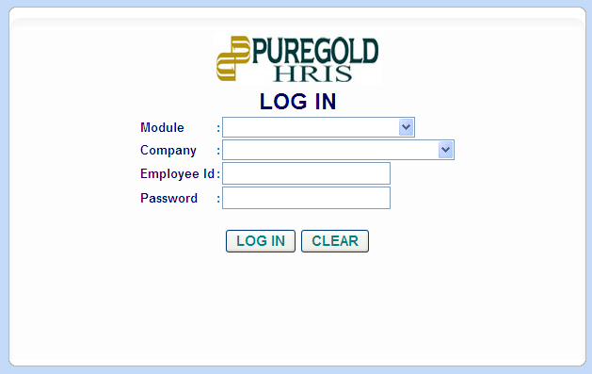
System Features:
- Supports any day as the employee’s rest day and not restricted to Sundays only.
- Keeps a data bank of all employees’ information (201 File).
- Generate reports such as PAF, Employee Movement, Employee Rank Report, etc.

LIST OF COMMON BUTTONS
 | Description / Function
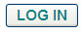 | - Used for the log – in Page
 | - Used to Lock and Log Out in the System
 | - Used to Search Engine.
 | - Used to Modify/Update Information.
 | - Used to Delete Information.
 | - Used to Add Information.
 | - Used to Print Reports.

- HOW TO’s:
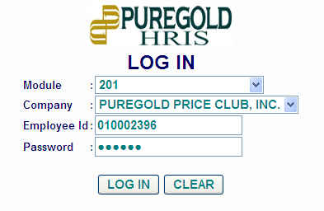
- LOG – IN PAGE
- Select “201” from the Module Dropdown list.
- Select company.
- Enter your Employee ID and Password.
- Then click the Log In button.

Note: Employee ID and Password will be given by the Admin User.

- PARTS OF THE MAIN SCREEN
    - The Header – includes the ff:
      - Module Name - Name of the module that the user currently access.
      - Name of the User - Name of the current user.
      - Company - Company where the user currently assigned.
      - Current Date / Time
      - Lock - Allows the user to lock temporarily the system.
      - Log Out

    - List of Available Menus
      - Depends on the access assigned to the current user.
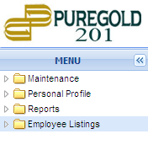

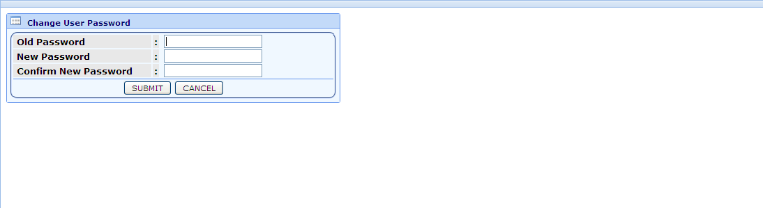
    - Main Screen

MAINTENANCE

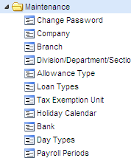  Maintenance Sub - Menus | Description
Change Password | Allows the user to modify his/her Password.
Company | Allows the user to view Company Information.
Branch | Allows the user to view Branch Information.
Division / Department / Section | Allows the user to view Division, Department and Section Information.
Allowance Type | Allows the user to view Allowance Type Information.
Loan Types | Allows the user to view Loan Type Information.
Tax Exemption Unit | Allows the user to view Tax Exemption set by the Bureau of Internal Revenue.
Holiday Calendar | Allows the user to view list of dates which is/are set as legal/special holiday.
Bank | Allows the user to view Bank Type Information.
Day Types | Allows the user to view Day Type Information
Payroll Periods  Note:  User can only access the said menu if the admin gives access to the user.  Table Maintenance does not appear? -> Contact the Admin.  The Admin has the capacity to do modifications such as Adding, Update and Delete Records in the Maintenance Module. | Allows the user to view list of pay dates including Start and End of Cut Off.

CHANGE PASSWORD
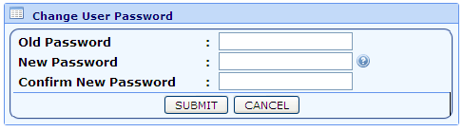
- Click Change Password Sub-Menu:
- Fill – Up the needed Information.
- Then Click Submit Button.

COMPANY
- Click Company Sub-Menu:
  - List of Companies will appear.
    - User may select from the list of available search type:
      - Name
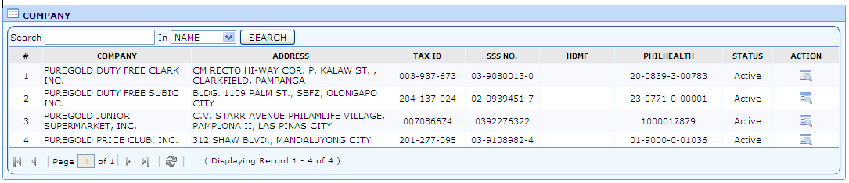
      - Address

  - Click View Button -> to check other information connected to the selected company.
Note:
Company Information is very important especially for Remittance Textfile, Accounting Purposes, etc.
Any wrong / misspelled information -> contact Admin, since the Admin has the authority to do modifications in the maintenance module.

BRANCHES
- Click Branch Sub-Menu:
  - List of Branches will appear.
    - Depending on the user’s selected company on the Log In Page.
      - User may select from the list of available search type:
        - Code
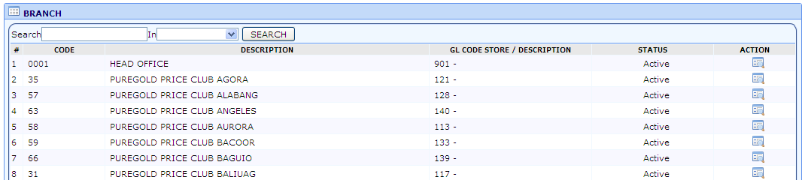
        - Description

  - Click View Button -> to check other information in connection to the selected branch.
Note:
Branch Information is very important especially for Employee 201 Data.
Any wrong / misspelled information -> contact Admin, since the Admin has the authority to do modifications in the maintenance module.

DIVISION, DEPARTMENT AND SECTION
  - Click Department/Section Sub-Menu:
    - 3 parts of the Department/Section Sub Menu:
 | Description
Division | Displays the current division set up of Puregold Price Club Inc.
Department | Displays the current department based on the Selected Division.
Section | Displays the current Section under the selected department and division.

Note:
The said module plays a very important role in 201 and Payroll System. (Manpower Count, Displays of Employee in the report.)
Any wrong / misspelled information -> contact Admin, since the Admin has the authority to do modifications in the maintenance module.

- DIVISION
  - Click Division Button.
  - Click View Button -> to view other information connected to the selected division.
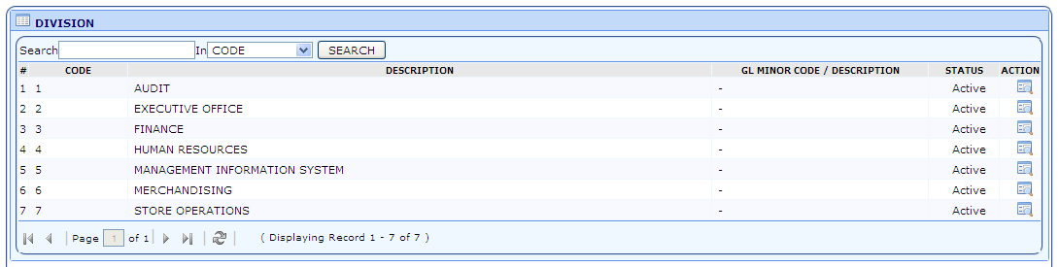

- DEPARTMENT
  - Click Department Button.
  - Select from the list of divisions -> List of Departments under the selected Division will appear.
  - User may select from the list of available search type:
    - Code
    - Description
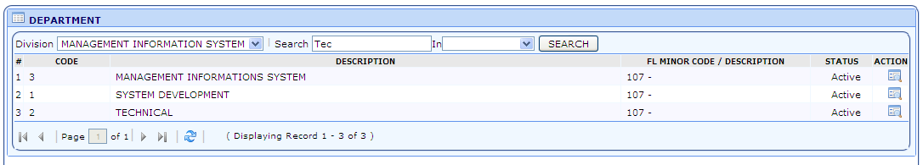

  - Click View Button -> to view other information connected to the selected Department.

- SECTION
  - Click Section Button.
  - Select from the list of divisions -> Select from the list of department -> Section under the selected division and department will appear.
  - User may select from the list of available search type:
    - Code
    - Description
  - Click View Button -> to view other information connected to the selected Section.
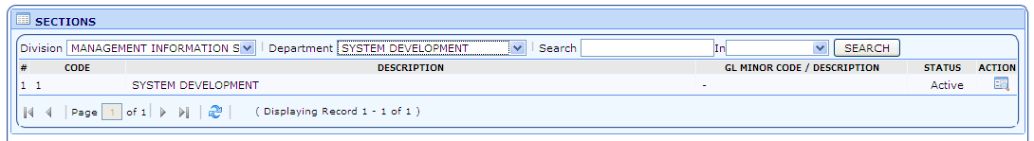

ALLOWANCE TYPES
- Click Allowance Type Sub-Menu:
  - List of Allowance Types will appear.
  - Click View Button -> to view other information connected to the selected Allowance Type.
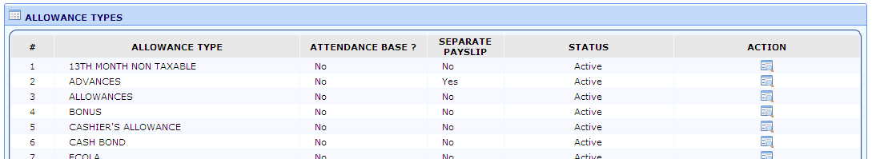

Note:
The said module plays a very important role in 201 and Payroll System. (Setting of Employees Allowance, Processing of Payroll)
Any wrong / misspelled information -> contact Admin, since the Admin has the authority to do modifications in the maintenance module.

LOAN TYPES
- Click Loan Type Sub-Menu.
  - List of Loan Types will appear:
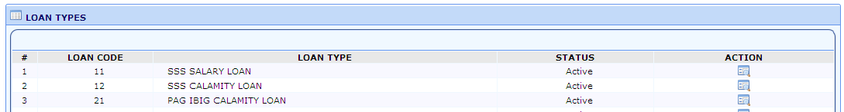
  - Click View Button -> to view other information connected to the selected Allowance Type.

Note:
The said module plays a very important role in Payroll System. (Processing of Payroll)
Any wrong / misspelled information -> contact Admin, since the Admin has the authority to do modifications in the maintenance module.

TAX EXEMPTION
- Click Tax Exemption Unit Sub-Menu.
  - List of Tax Exemption will appear based on the Tax Exemption set by the Bureau of Internal Revenue.
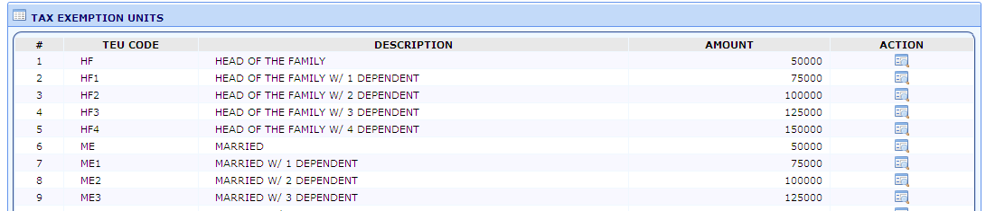

HOLIDAY CALENDAR
- Click Holiday Calendar Sub-Menu:
  - List of Holiday Dates will appear.
    - User may select from the list of available search type:
      - Holiday
      - Branch
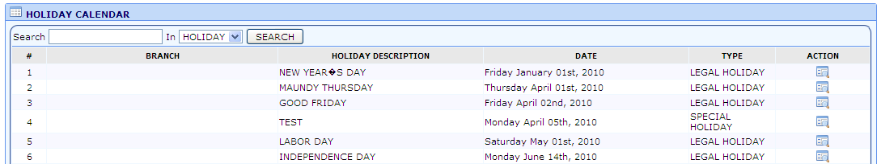
      - Year

Note:
The said module plays a very important role in Time Related Computations and Payroll Processing.
Any wrong / misspelled information -> contact Admin, since the Admin has the authority to do modifications in the maintenance module.

BANK
- Click Bank Sub-Menu:
  - List of Bank Types will appear.
    - User may select from the list of available search type:
      - Bank
      - Branch
      - Address
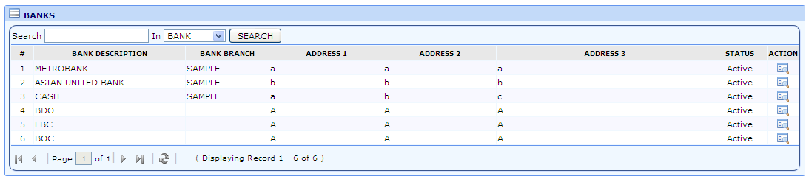

DAY TYPES
- Click Day Types Sub-Menu:
  - List of Bank Types will appear.
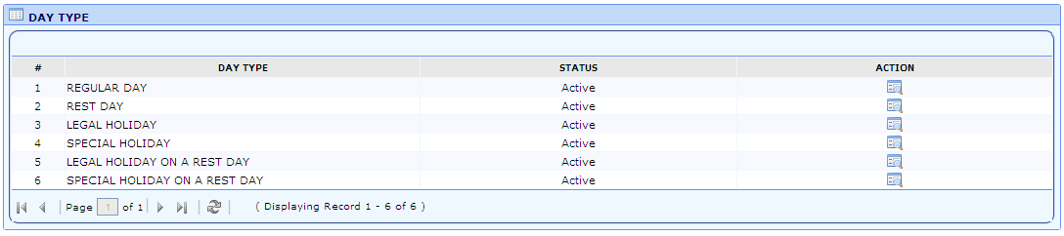

PAYROLL PERIODS
- Click Payroll Periods Sub-Menu:
  - List of Payroll Periods Appear. ( By Pay Category, Group and pdNumber.
    - User may select from the list of available search type:
      - Year
      - Pay Cat
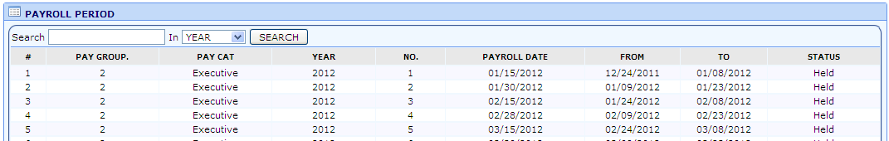

PERSONAL PROFILE

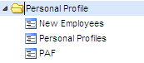
Personal Profile Sub - Menus | Description
New Employees | Allows the user to encode new Employees.
Personal Profile | Allows the user to view, edit, PAF the selected Employee.
PAF | Allows the user to view PAF Transactions.

- Double click the Personal Profile Menu, and then click New Employees Sub - Menu.
  - List of new employees will appear.
  - User may select from the list of available search type:
      - Employee No.
      - Last Name
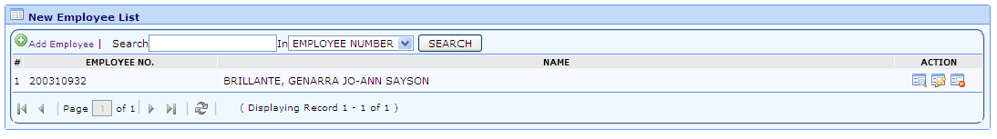
      - First Name

Note:
List of employees depends on the Branch Code of the Log In User.

TO ADD NEW EMPLOYEE RECORD
- Just click the Add New Employee button.
  - Enter all the necessary employee information.
Note:
Some fields are required.
The System can checked if the :
Employee No. Exists.
The Employee is blacklisted.
Encoded SSS, TIN, HDMF No. already exists.
If the needed data is not available, kindly inform the Assigned HRD HO User.

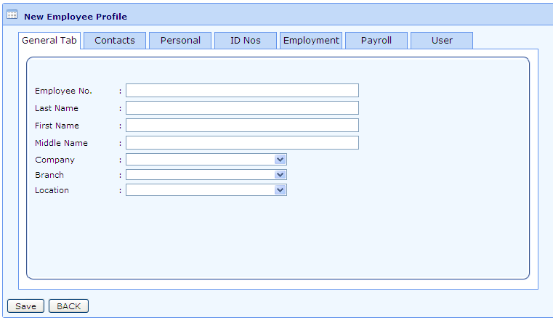

  - Types of Employee Information:
      - General Tab
      - Contacts
      - Personal
      - ID Nos.
      - Employment
      - Payroll
      - User

  - Click Save button to Save the Record.

TO VIEW THE ENCODED NEW EMPLOYEE INFORMATION

- Just click the View Employee information button of the selected employee.

TO EDIT THE ENCODED NEW EMPLOYEE

- Just click the Edit Employee button on the action column of the selected employee.
  - The user may now modify the encoded/available information.
  - Then click the Save button to update the employee record.

TO DELETE THE NEW EMPLOYEE RECORD

- Just click the Delete Employee Record button of the selected employee.
  - A confirmation message will appear, click “OK” or “Cancel”.
Note:
OK Button – Record will be deleted.
Cancel Button

TO PRINT PROOFLIST OF ALL THE ENCODED NEW EMPLOYEES

- Click the Reports Menu, and then click New Employee Proof list Sub - Menu.
  - Click Inquire radio button.
  - User may select from the list of available search type:
    - Status – Released / Held
    - From and To Date
    - Division
    - Department
    - Section
  - Click New Employee Proof list Button.

TO RELEASE THE EMPLOYEE (SET THE NEW EMPLOYEE AS PART OF THE COMPANY)

- The user may:
  - After filling up the needed information upon adding.
  - Click the Edit Employee button on the action column of the selected employee.
- Just check the Release check box besides the Save button.
- The new employee record will be added to the employee master list.

PERSONAL PROFILES

- Double click the Personal Profile Menu, and then click Personal Profiles Sub-Menu.
  - List of all employees will appear including (Probationary, Regular, Contractual, Resigned, and Terminated).
    - User may select from the list of available search type:
      - Employee Number
      - Last Name
      - First Name

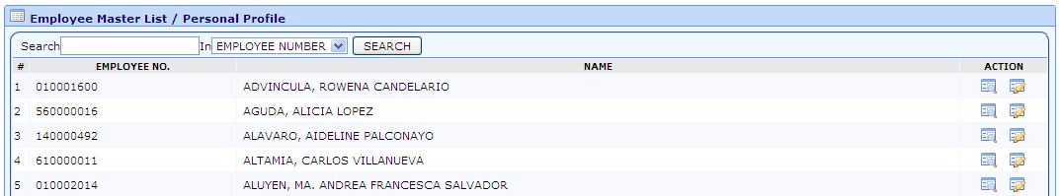

Note:
List of employees depends on the Branch Code of the Log In User.

TO VIEW THE CURRENT EMPLOYEE INFORMATION

- Click the View Employee Information button of the selected Employee.

  - Thru View Employee Information :
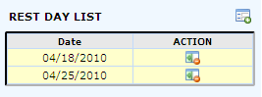

    - User can add rest day of an employee.
      - By clicking the Employment Tab.
      - Click add rest day button.
        - Popup window will appear.
        - Select the date of employee rest day.
        - Then click save button.

    - To delete the Encoded rest day of the selected employee.
      - Just click the delete rest day button.
      - Confirmation message will appear.

TO FORCE EDIT EMPLOYEE INFORMATION

- Click the Edit Employee Information button.
  - User may now modify the current Employee Information.
  - Click Save button to update the employee record.
Note:
Not all Information will be displayed, especially for the employees who are tagged as “EXECUTIVE”.

TO ADD/UPDATE/DELETE ALLOWANCE
- Select Employee.
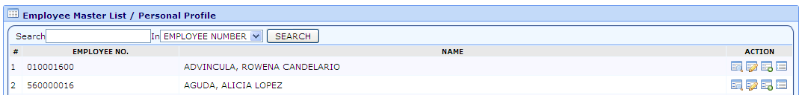

  - Click Employee Allowance Button.
  - User may select from the list of available search type:
      - Allowance Code
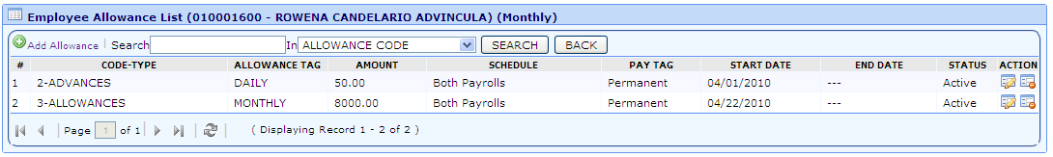
      - Allowance Description

TO ADD ALLOWANCE
      - Click Add Allowance Button.
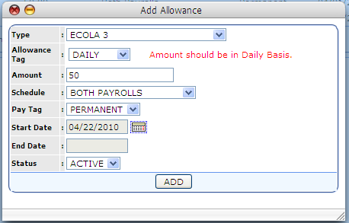
        - Fill-Up the needed information:
          - Type – refers from the list of available Allowance Type.
          - Allowance Tag – refers to the Distribution of Allowance Amount if it is Monthly or Daily Basis.
          - Schedule – refers to the type of cut off of the payroll period.
          - Pay Tag – refers to the range of the allowance if it is PERMANENT or TEMPORARY.
        - Click Add Button.

TO EDIT ALLOWANCE
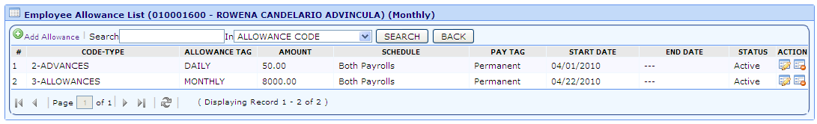

      - Click Edit Button.
        - Do the necessary modifications.
        - Click Edit Button.

TO DELETE EXISTING ALLOWANCE
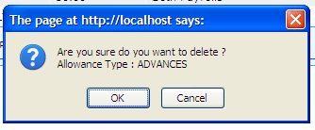
      - Click Delete Button.

FOR HEAD OFFICE:
PAF THE SELECTED EMPLOYEE
- Select the employee, and then click the Add PAF button.
  - Action Type module will appear:
    - In the Action Type Module:
      - The user may add, edit, and delete PAF entries which are tagged as ‘Held’ and ‘Released’.

ADD PAF TO THE SELECTED EMPLOYEE
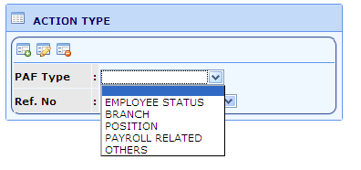

  - Add PAF By :
      - Employee Status
        - The user can change or update the employee status of the
Employee.
        - The user must fill up the needed information.
        - Click Save Button.

      - Branch
        - The user can change or update the payroll group, and the current branch of the employee.
        - The user must fill up the needed information.
        - Click Save Button.

      - Position
        - The user can change or update the current position of the selected employee.
          - Once the user selects a position, there will be an automatic cascading of division down to level.
          - Click Save Button.

      - Payroll Related
        - The user can change or update the current payroll status (‘Monthly’ or ‘Daily’), monthly rate, daily rate, hourly rate, tax exemption, bank and account no., payroll group, and payroll category of the selected employee.
        - The user can also add/modify existing allowance for the selected employee.
          - Just click the View/Edit allowance button:
            - Popup window will appear.
              - The user must fill up the needed information.
              - Click Save Button.
      - Others
        - The user can change or update the other information of the selected employee such as Employee Last Name, First Name, Middle Name, Address, SSS No., Phil Health no., Tax ID No., and HDMF No.
        - Click Save Button.

  - All NEW PAF entries will be automatically tag as ‘Held’.

TO EDIT PAF RECORD OF THE SELECTED EMPLOYEE

    - Click PAF Button.
      - Select the appropriate PAF Type.
      - Select the reference number.
      - Click the Edit button.
        - Do the necessary modification.

TO DELETE PAF RECORD OF THE SELECTED EMPLOYEE

    - Click PAF Button.
      - Select the appropriate PAF Type.
        - Select the reference number.
          - Then Click the Delete button.
      - A confirmation message will appear.
Note:
        - OK Button – Record will be deleted.
        - Cancel Button

TO VIEW ENCODED/HELD/RELEASED/POSTED PAF’S

    - Double click the Personal Profile menu, and then click PAF sub-menu.
      - A list of all PAF entries will appear.
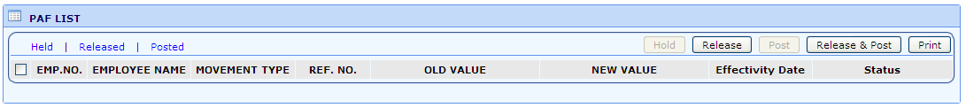

HOW TO VIEW ALL THE PAF ENTRIES WHICH ARE TAGGED AS:
        - HELD
          - Just click the Held link.
        - RELEASED
          - Just click the Released link.
        - POSTED
          - Just click the Released link.

HOW TO TAG PAF TO (HOLD, RELEASE, POST, RELEASE AND POST)

        - User may select:
          - “ALL” - by clicking the upper checkbox on the left side of the Employee No. table header.
          - “INDIVIDUAL PAF’s” – by clicking the checkbox on the left side of Employee No..

        - To Hold the PAF:
          - Check the PAFs you want to be tag as Hold.
          - Then click the Hold button.
Note:
            - Only released PAFs are allowed to be hold.

        - To Release the PAF:
          - Check the PAFs you want to Release.
          - Then click the Release button.
Note:
            - Only Held PAFs are allowed to be Release.

        - To Post the PAF entry:
          - Check the PAFs you want to Post.
          - Then click the Post button.

Note:
            - Only Release PAF’s is/are allowed to be posted.

        - To Release and Post PAF entry:
          - Check the PAFs you want to release and post.
          - Then click the Release and Post button.
Note:
            - Only PAFs that are tagged as ‘Held’ is allowed to be Released and Posted.

HOW TO PRINT PAF

        - Different PAF Report:
          - Personal Profile Menu
            - PAF Report via PAF List
              - Can be:
                - By BATCH.
                - By Selected Employee PAF.
          - Reports Menu
            - PAF (HELD) Proof List - PAF tagged as Held.
            - PAF (RELEASE) Proof List – PAF tagged as Released.
            - PAF (POST) Proof List -– PAF tagged as Posted.
            - Salary Increase Reports

        - PAF Report via PAF List

          - Click Personal Profile Menu, then click PAF sub menu.
            - PAF Reports via PAF List can be:
              - BY BATCH
              - BY Selected Employee PAF.
            - Click Print Button.

        - Reports Menu
          - Click Reports Menu:
            - Click PAF Prooflist Sub Menu:
              - User may filter by:
                - PAF Type
                - From and To Date
                - Division
                - Department
                - Section
                - Emp #
                - Employee Name
              - Click PAF Prooflist Button.

            - Click Released PAF Sub Menu:
              - User may filter by:
                - PAF Type
                - From and To Date
                - Division
                - Department
                - Section
                - Emp #
                - Employee Name
              - Click Release PAF Button.

            - Click PAF Sub Menu:
              - User may filter by:
                - PAF Type
                - From and To Date
                - Division
                - Department
                - Section
                - Emp #
                - Employee Name
              - Click PAF Button.

OTHER REPORTS
  - Reports Menu
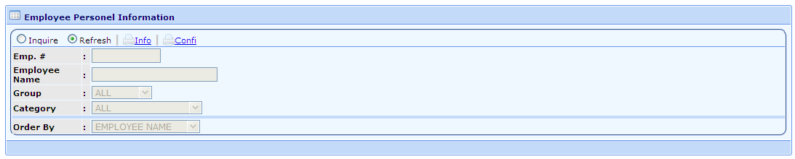
      - Employee Personel Info.

        - Displays employee’s 201 information including allowances information.
        - Click Inquire radio button.
          - User may:
            - Encode Employee No.
            - Search Employee – by pressing “Enter” on the keyboard.
              - Select the Employee by click the Select Employee Button.
            - Click either:
              - Info Link – Display Personal Information of the Employee.
              - Confi Link - Display Employee Salary.
      - COE
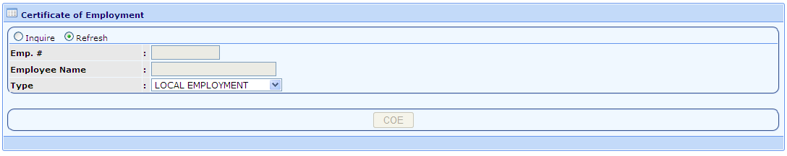
        - Allows the user to print Different kinds of Certificate of the Selected Employee.

        - Click Inquire radio button.
          - User may:
            - Encode Employee No.
            - Search Employee – by pressing “Enter” on the keyboard.
              - Select the Employee by click the Select Employee Button.
            - Select from the List/Type of Certificate.
            - Click COE Button.
      - Employee Status
        - Display List of Employees under certain Employee Status.
        - Click Inquire radio button.
        - User may select from the list of available search type:
          - Status
          - From and To Date
          - Division, Department, Section
          - Employee No.
        - Click Employee Status Button.

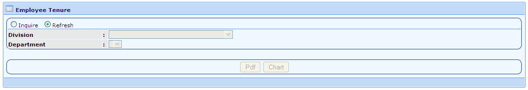
      - Employee Tenure

        - Display Tenure of Employees being grouped by Division and Department.
          - Click Inquire radio button.
          - User may filter the display of report by:
            - Division
            - Department
          - Click either:
            - PDF Format
            - Chart Format

      - Employee Listing
        - Listing Report By Payroll Type
          - Allows the user to generate report based on the current Employee Rank.
          - Click Inquire radio button.
          - User may filter the display of report by:
            - Branch
            - Division
            - Department
            - Section
          - Click Generate Listing Report Button.

        - List of Employees With Salary
          - Allows the user to Generate report which contains the Employee Salary and Allowance Information.
          - Click Inquire radio button.
            - User may filter the display of report by:
              - Branch
              - Pay Category
              - Division
              - Department
              - Section
            - Click Generate Listing Report Button.

